Smart Health Monitoring System Using IoT and IFTTT

Balakrishna Sani1, Jayanth Kammela2, Shanmukh Sujuth Sai Karri3, Pamidi Vivekananda Reddy4, Dara Dev Kiran5, Ch. Ravi Shankar 6  
 *Electronics and Communication Engineering, Lovely Professional University, Punjab, India*  
1 sanibalakrishna@gmail.com, 2 jayanthkammela@gmail.com, 3 shanmukh1651@gmail.com, 4 pamidivivek@gmail.com, 5devkiran4632gmail.com, 6 ravi.14909@lpu.co.in

*Abstract*— IoT Internet of Things is one of the most useful inventions that humanity has ever invented. We all know that for reading any of our body parts reports we must take the help of different sensors for reading data from the patient in every single activity like calculating Heartbeat, Temperature, SpO2, Blood Pressure, etc... of the patients. This is where we observe the importance of the IoT. The implementation of a smart health monitoring system is one of them that can bring a major change in the field of Health Care. It can be used for daily testing of the most common readings of health reports such as temperature, bpm, SpO2 levels, and ECG. It can also be instead used as a family doctor for a minor health check-up at home, saving money and time. This is a combination of the temperature, heartbeat, oxygen saturation (SpO2), etc... sensors that collect all the data to the Arduino UNO microcontroller then to server thing speak using Node MCU update the same in the Android app too. If there is an emergency it will send a notification to the doctor, or guardian through email and voice call.

Keywords— Arduino UNO, Health Monitoring, IFTTT, Serial Communication, Thing speak Cloud.

# Introduction

The Internet of Things (IoT) represents an online concept that reaches the real world with all its uses in our daily lives. It is present in everything that we use and observe in our daily lives. In the digital world, everything is based on IoT [3]. A person can access all his everyday objects such as smartwatches, laptops, smartphones, etc... these devices have embedded technology which is a subset of IoT this is only possible due to IoT. IoT is also used in artificial intelligence in some of the trending technologies that we all use in our daily life such as voice recognition, face recognition, and fingerprint devices embedded into mobile phones using IoT [1]. The Self Driving System implemented in most modern cars like tesla's where this technology is dependent on sensors like ultrasonic etc... [3] sending ultrasonic waves to detect the object near it and its shapes with the help of IoT and Artificial Intelligence. IoT also plays a major role in the field of health care just imagine if there were no sensors for calculating any sort of important reading from the patient's body, especially the most common reading like temperature, SpO2, etc... [22]. These readings like temperature, heartbeat, and SpO2 may seem to be normal [8]. But these readings are very important in the field of medical science by which the status of the affected disease can be measured, or the symptoms of the many diseases can be found in the early stage of the disease which may help to prevent the disease. It would be very difficult to even imagine if there are no more sensors that can help us in health care than most of our lives would be in danger. Most of the things possible today in the field of health care especially due to IoT. We can also observe more and more improvements that we can find day to day in the field of health care based on IoT. IoT makes our lives not only smarter but also easier with all its applications.

It also helps in terms of accessibility of everything from anywhere in the world like providing remote access for everything like access the remote controlling the thing like a light in a house, the motor in an agricultural field from all over the world and helps a doctor in someplace in the world can analyze the health status related to a disease of a patient who is present in some other part of the world this type of real-time remote monitoring system the IoT will also, play a major role [3].

It helps to track the health status of patients. Using a variety of sensors max30100 which helps to read the heartbeat and SpO2 level of the patient with a scan of the patient's finger[8], Lm35 to read the temperature from the patient, and AD8232 for the ECG generation of the patient a microcontroller[21] Arduino UNO that can track the patient's health reading according to the patient's body temperature, heart rate, SpO2, and ECG, collect data from all these sensors about the condition of the respective patients send it to a cloud [Thing speak] using Node MCU which is a microcontroller integrated with Wi-Fi module which is connected to Arduino UNO, send data to mobile app and this information can also be shared with your doctor stored in google sheet with help of webhooks and IFTTT[23]. This health monitoring system setup helps us to measure a person's body temperature, oxygen level, and heart rate [2]. During pandemics, people are afraid to go to the hospital to check the health status of their family members due to the uneven situation [10]. But by using this health monitoring system they can do the same thing in their homes without any sort of worry, and this can be used in hospital wards to save manpower and avoid contact with the staff. This System can help in ICUs where every second of a patient's health status should be monitored in real-time and this system can help if there are any emergencies there could be cases where the doctor may or may not be near the patient this will help at such situation by send the phone call and email to the doctor [9]. This can also help the old people because many of them are in a stage where they can't be taken to the hospital frequently for health check-ups this smart health monitoring system can help you in such a situation to make the work done at home without any stress of taking them to the hospital every time [12]. It collects all the data of one patient about his or her heart rate, oxygen level, body temperature, and ECG [13]. If the system finds any abnormalities in his or her health inform both physician and patient by email and phone call. This present system has much future scope where the collected data on patients' health status in the form of google sheets can be used in medical research.

# methodology

In this paper, we have proposed both the software and hardware implementation of the smart health monitoring system for a detailed understanding of the model.

## Software Model

First, we used the most used IoT software simulator tool Proteus where we get access to a large number of IoT sensors, microcontroller boards, etc... with the help the Proteus we build our software model with components required by our system, which are available on proteus [23]. The most important thing that we need for our model is a Microcontroller board which helps in collecting data from the different sensors like lm35, heartbeat in the proteus which helps us for providing the reading of both temperature and heartbeat the power and ground of each sensor are connected to the general power supply to provide the power for the sensors then the data signal of the both are connected lm34 data pin to the A0 analog input pin of Arduino UNO because we get an analog reading from the lm35 in terms of millivolts later we use some formulae to convert this analog value into our required format of temperature it could be Celsius or Fahrenheit [11]. Similarly in the case of the heartbeat sensor to we would take the help of a push-button and timer from 1 to 10, then multiply the heartbeat count from the sensor by 60 which is counted when the button is pushed, and the timer is started from 1 and ends the count when the timer reaches the 10. This data from the sensor can be viewed in the proteus with the help of the LCD 20X4 display which is connected to the Arduino UNO with pins from 8 to 13 in it to the LCD required data pins (D7, D6, D5, D4), enable to 12, reset to the 13 and remaining pins to the power supply so we can observe the reading on the LCD when we provide readings to the sensor.

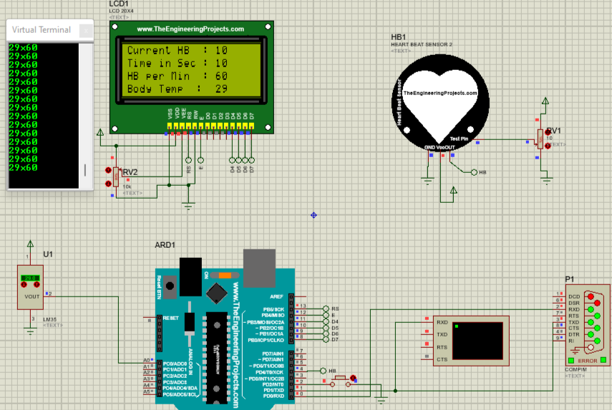

Fig. 1. Proteus software simulation model.

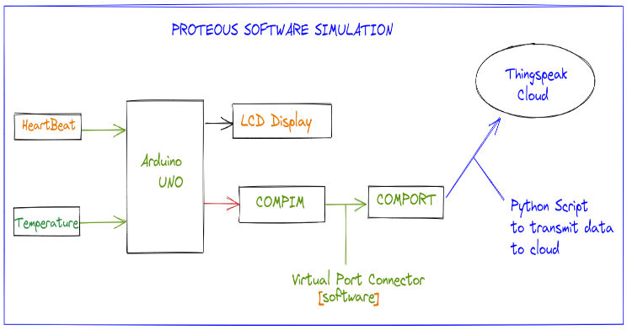

Fig. 2. The architecture of the software model.

Later to provide this data we the cloud in the hardware model we take the help of Node MCU. But in the proteus, we have no such Wi-Fi-related libraries or modules to send the data from the proteus. So, we took the help of compim in proteus which helps us to access the comport later we will use a virtual port connector software that helps us to create a virtual port that is connected to the comport created using the compim. Then we use a Python script in the background by using its URL, timer libraries, etc…we can access the data from the virtual port COM3 with the baud rate (9600). Then divide the single data into pieces and update these values to the cloud using the writing API Keys of the thing speak cloud later we will call this function every 5 seconds for the value update to the cloud. Later we can send this data to the Android App that we have built which works in real-time and collects the data to Google Sheets etc..

## Hardware Model

In the Hardware proposal, we are trying to achieve a model which can overcome some of the problems facing these days in health care related to check-ups, an alert system to notify through the mail and a voice when emergencies and collect data for the research. The sensors and hardware used in the model are.

#### 1) Hardware Components

Node MCU ESP 8266, Arduino UNO, LM 35, MAX30100, and ADA8232.

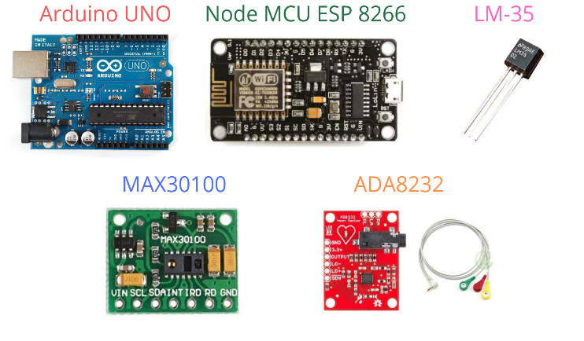

Fig. 3. Hardware Model Components.

*2)Working*

We are using the most common sensors for collecting the data from the patient for the readings like temperature, heartbeat, SpO2, and ECG. We used LM35 to collect the temperature readings, Max30100 for collecting the data related to the heartbeat and SpO2, and then finally ECG for collecting the Electrocardiography. We have connected all the VCC and ground of each sensor to the power supply then the data pins of the sensors to the Analog input of the Microcontroller Board Arduino UNO LM35 to the A0, ADA8232 ECG sensor output data to the A2, and two output pins form the MAX30100 named SDA, SCL with A4 and A5 of Arduino UNO to collect the data from all the sensors and then form one single string which is a sentence in the programming languages where is the values are separated using the Alphabets from 'A' to 'D' [19]. Because we are sending this data to the cloud using Node MCU which is a microcontroller integrated with a Wi-Fi module that helps in sending the data to the cloud [17]. We connect the Arduino UNO to Node MCU using serial communication.

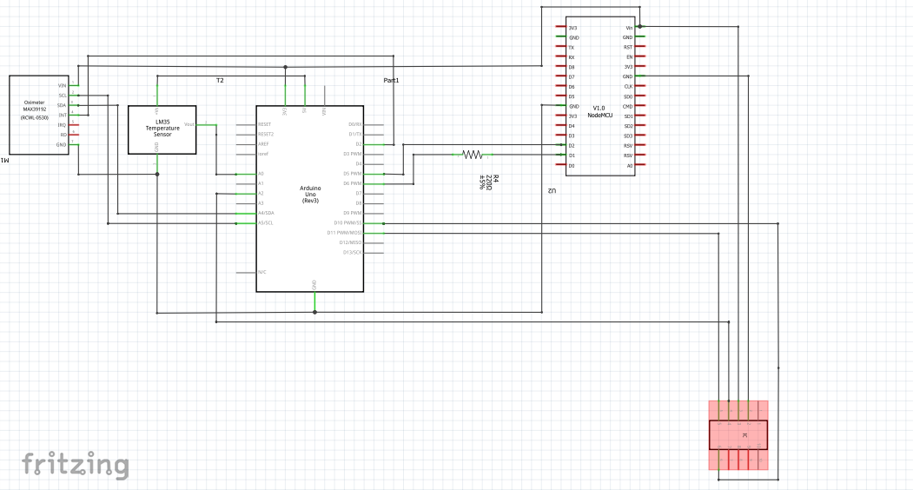

Fig. 4. Schematic of the Hardware model.

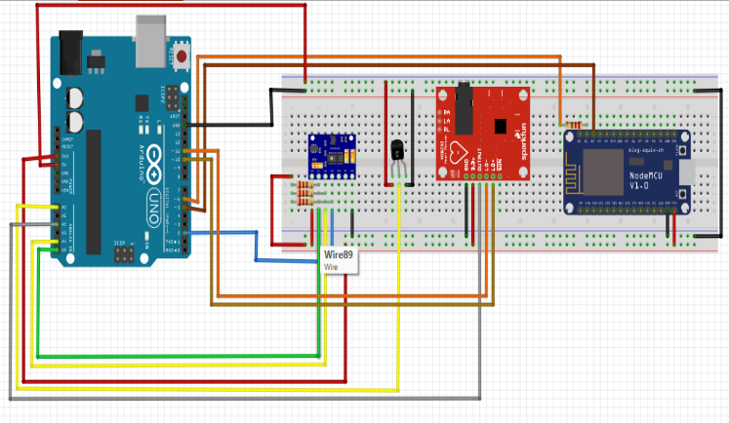

Fig. 5. Hardware model circuit.

3) *Serial Communication*

This is a process by which any two microcontroller boards can connect with the help of the Rx(receiver) and Tx(transmitter) pins of both the board in simple words. Where the Rx pin of one board is connected to the Tx pin of another board and similarly, the Tx pin of the first board is connected to the Rx pin of the second board. So that they can communicate with each other using this way. We are trying to do this same Serial communication between the Arduino UNO and Node MCU because Node MCU is a microcontroller integrated with the Wi-Fi module ESP8266, but it has a major issue of having only one Analog pin. But in our system, we need more analog pins for different sensors, so we are using an Arduino UNO which has more analog pins compared with Node MCU [7]. The Software Serial Library in Arduino IDE with the help of which we are using Serial Communication to send the data from the Arduino UNO to Node MCU then in it we will separate the data with help of alphabets used before in Arduino UNO and Send this data to the cloud using the thing speak library with the help of writing the data with direct function using our Writing API key and Channel Id of the thing speak cloud [4]. When we compare this model with the software model we have avoided part of the LCD display because there could be cases where the patient can get into tension or worry about their condition if there are any emergencies they would be overthinking the situation which can lead to any other health issues like a heart attack or high Blood Pressure etc...Instead, we have used a mobile application that helps with real-time monitoring of the reading from the patient [15].

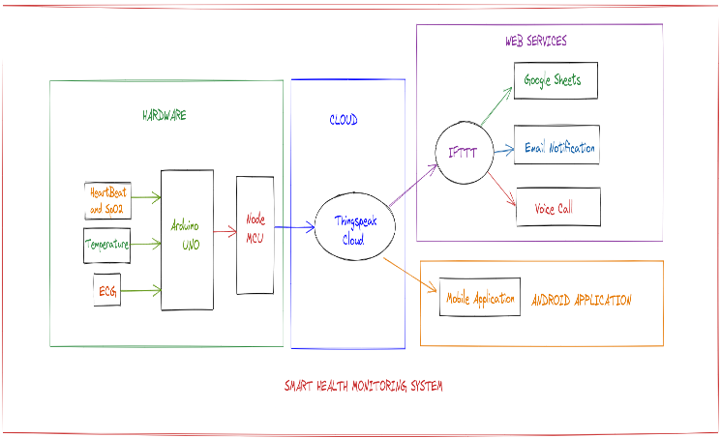

Fig. 6. Block diagram of working hardware model.

*4) Mobile Application*

We have created an Android with the help MIT app inventor provided by MIT which is a no-code android development platform where any beginner can build his or her own design for both the android and IOS devices [6]. Where we can design our model for the front, we will work with the User Interface when we design home page buttons, icons, text that can be viewed by the end-user, and for the backend, we basically connect the blocks which will then help us to build the logic that we can build using coding instead with the help of block to connect with each other [7]. We have created an App that is required for our system to numerically display the values of all the sensors in real-time. This app basically has a home page when we start the app we can observe a vertical alignment with four horizontal alignments which has two components on each alignment one is an icon of temperature, heartbeat, SpO2 level, and ECG where all these icons themselves are individual buttons which would redirect us to the graph of values which is collected in the cloud in a graphical representation which help in some case even user can analysis his reading increment as well as decrement with the values, along with this we also have the real-time updated numerical values next to each of these icons[5]. Then we can find a check-up icon downward which determines basic conditions with an alert when some uneven values are found it would provide some advice and alert [16]. Then finally a database button redirects to the data collected with the timestamp in Google Sheets.

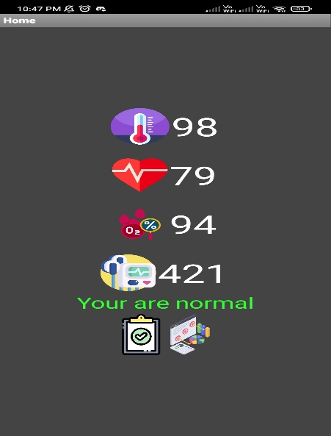

Fig. 7. Android Mobile Application.

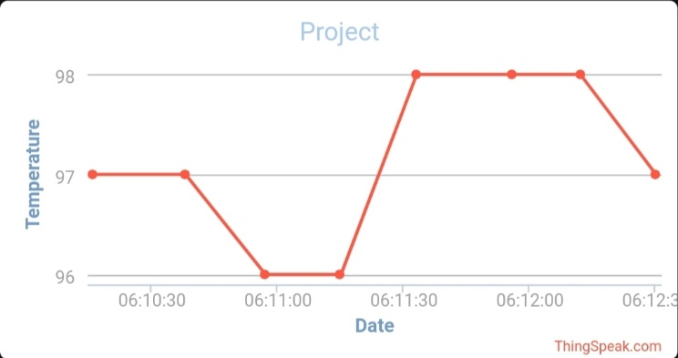

Fig. 8. Temperature Graph when tapped on the icon.

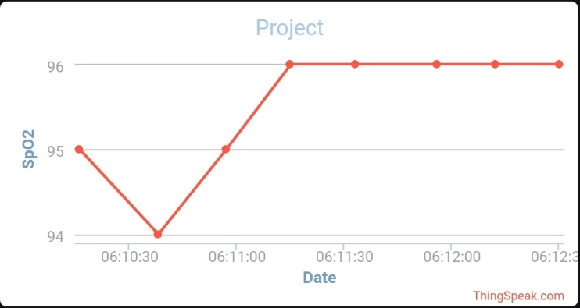

Fig. 9. SpO2 values Graph.

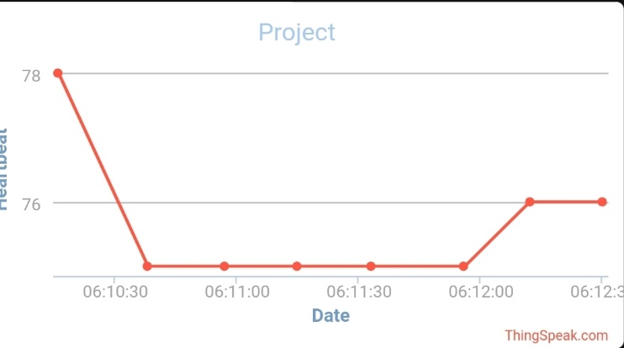

Fig. 10. Heartbeat Graph.

ECG general helps to diagnose heart arrhythmias, heart attacks, pacemaker function, heart failure, etc... The waveform components produced indicate cardiac electrical activity. When we find the first upward of the ECG tracing is the P wave. It indicates atrial contraction. The QRS complex begins with Q, a small downward deflection which is then followed by a larger upwards deflection, a peak(R), and then a downwards S wave. This QRS complex indicates ventricular depolarization and contraction.

Fig. 11.ECG signal in detail.

Finally, the T wave, which is normally a little upwards waveform, represents ventricular repolarization.

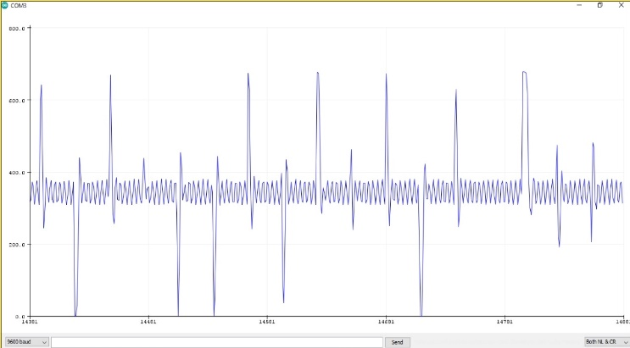

Fig. 12. ECG from the Hardware model.

*5) IFTTT*

IFTTT means “If This, Then That” it is a fairly trouble-free web service provider company that allows its users to trigger some of the most commonly used services like Alexa, email, phone calls, SMS, posting some content on social media sites, etc... when a response is sent to the IFTTT[24]. Which is used for webpage protocol which makes the complex process more simple and easy to use[14]. As its name indicates "If This, Then That" where the "If This" part is the response from a website or a react app or given conditions, "Then That" part is the main trigger part they are the output produced for the input response given to IFTTT[22]. It has Applets which are also known as "recipes" these are the predicates made from Triggers and Actions. It also has Ingredients that are the basic data available from a trigger.

IFTTT is used for collecting the all data from things speak and it will transfer the data to a google spreadsheet. It checks the data if there is any abnormal about the user and it will directly send a notification alert to the mail and it will send a voice message about the user's condition.

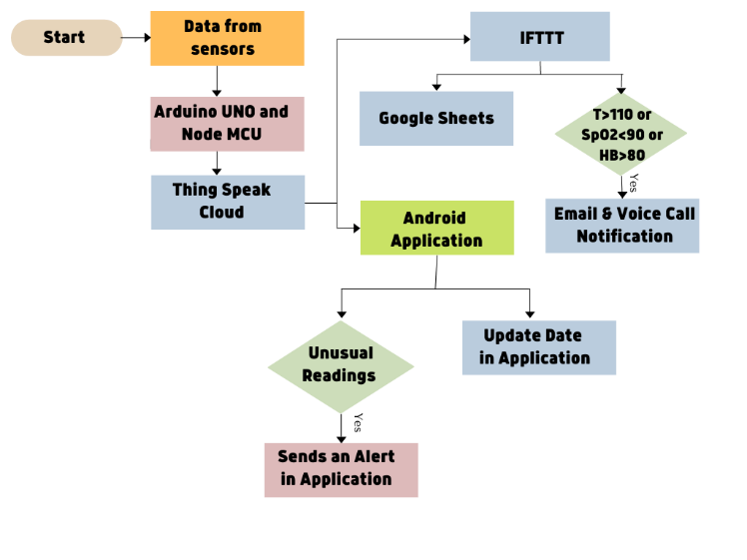

Fig. 13. Flow chart of the model

After sending the data to the thing speak cloud later using the IFTTT web services as shown in figure 13. we use the IFTTT for two cases from the fig-20,

Case-i

In IFTTT by using webhook with the help of web request from the think speak cloud react app by giving the conditions like temperature >100 or SpO2 <90 or Heartbeat is >80 we will consider these cases as emergencies then think HTPP in the thing speak cloud with the IFTTT webhook URL trigger with body paragraph which has values of temperature, SpO2, and heartbeat collected from the thing speak.

We also use the IFTTT for a similar sort of trigger for the voice call when the above emergency is triggered then it will send the voice call indicating a bit of advice to reach a nearby hospital along with the values of temperature, heartbeat, and SpO2.

Case-ii

We also take the help of IFTTT for collecting the new data from the think speak cloud when the new data from the hardware model from node MCU is updated to the cloud and we use a similar type of triggering a response from the thing speak cloud with the help of react app with the condition every time the data is updated to the cloud which just calls the thing HTTP Which has the body with the values then update this to the trigger which updates the data collected from the thing speak to the Google Spread Sheet[17].

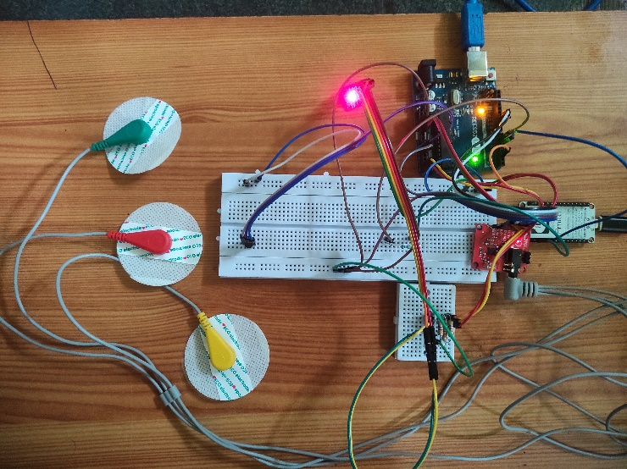

Fig. 14. Hardware Model

Similarly, we use some of these with the android app too. In the Android app with the help of the reading API URL, we would call it to update the values of temperature, heartbeat, and SpO2 in the android application when there is an update in the values in the thing speak cloud. presenting the values below, we have the check-up button left corner these are the basic conditions.

Case(i) Temp>100 & Sp02< 90 % then in this case we update the text as “your spo2 is low, temp is high. Please consult the doctor”.

Case(ii) Heartbeat >80 bpm & Sp02< 90 % then in this case we update the text as “your Spo2 is a little low, heartbeat is fast. Please reach the hospital”.

Case(iii) Temp >100 then in this case we update the text as “your temperature is high; you have a chance to get a fever. Please reach a nearby hospital”.

Case(iv) normal then in this case we update the text as “you are normal”.

# results and discussion

The system that we have proposed for the smart health monitoring system has two models both software and hardware models. The software model is implemented for the basic understanding of the working of the model even possible through software simulation. we can clearly observe how the data is sent to the cloud thing speak in our case in figure 2. Similarly, we are sending the data to the cloud in the hardware model we can observe in figure 14. But In this system, we are mainly focused on collecting the data of all the values of temperature, SpO2, and heartbeat to a google spreadsheet which can be later used by the doctor for analysis of a disease or this google sheet which is similar to CSV which is most commonly used format for training the machine learning model with the data that we have collected from that patients for the early disease prediction with the variation in readings of temperature, SpO2, and Heartbeat, etc...

We also proposed this system to notify the doctor, or guardian with the notification system through the Email system and send a voice call of the status of readings through the IFTTT App. This is the most underrated update because this can use in ICUs where the system notifies the doctor with a voice call and email when there is a sudden emergency with the patient it will notify in seconds.

After the implementation of the hardware system model, we have observed that the readings are updated to the Android app made with MIT App Inventor in real-time even before being displayed in the thing speak cloud sever [6]. The notification to the IFTTT app through voice call as well as the Email is updated in real-time from the time of both the voice call from figure 17 as well as the Email from figure 16 at the same time. In the same instance, we have even our database google spreadsheet values updated in real-time.

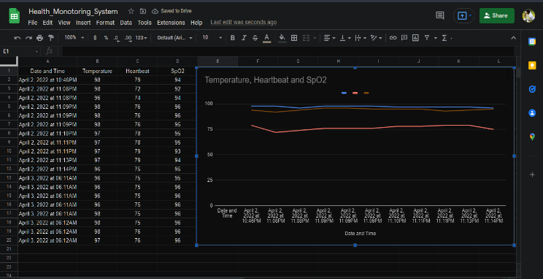

Fig. 15. Data Collected in Google Sheet.

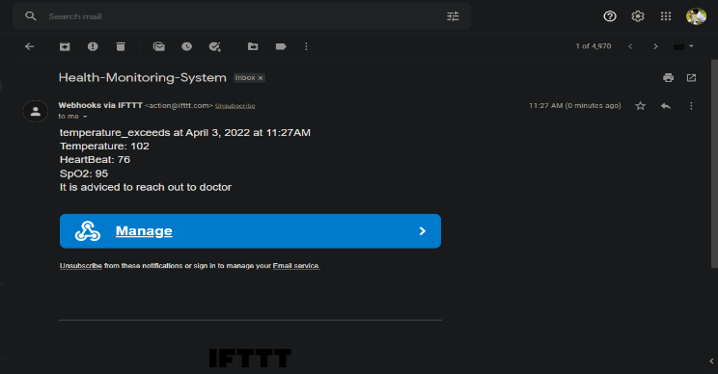

Fig. 16. Email Notification.



Fig. 17. Voice Call Notification.

# conclusions and future work

In this paper finally, we have presented both the working prototype of software simulation as well as the experimental hardware model of the smart health monitoring system in this model the components used are cost-effective which makes this accessible to all types of people who can use this in their home can save time, money, etc… this can be used in emergency purposes like recent pandemic where one can’t reach the hospital at the situation for a check-up and can be used with old where we need ECG real-time monitoring with this simple setup. This can be implemented in the ICU and connect with the doctor who is in charge with the patient gets

notified during immediate emergencies in real-time.

In these ways, this system can save us in many situations and help us in advance with the disease. The data collected in the sheets we can mintage security because only the authorized person has the access to them.

We all knew that IoT is a never-ending technology so there would always be some space in any domain for the sake of improvement. Similarly, we can make some future improvements even in this system we can take the help of trending technologies like Artificial Intelligence, and Machine Learning models for predicting some diseases by training the data collected using google sheet which are the most used data sheets to train a model. we can also expand the scale of sensors with commonly used necessary reading sensors. Built the system as small size as possible that makes the system portable like the watches we carry.

##### References

1. Kajornkasirat, S., Chanapai, N., & Hnusuwan, B. (2018, April). Smart health monitoring system with IoT. In 2018 IEEE Symposium on Computer Applications & Industrial Electronics (ISCAIE) (pp. 206-211). IEEE.
2. Rahaman, A., Islam, M. M., Islam, M. R., Sadi, M. S., & Nooruddin, S. (2019). Developing IoT Based Smart Health Monitoring Systems: A Review. Rev. d'Intelligence Artif., 33(6), 435-440.J. Clerk Maxwell, A Treatise on Electricity and Magnetism, 3rd ed., vol. 2. Oxford: Clarendon, 1892, pp.68–73.
3. Vippalapalli, V., & Ananthula, S. (2016, October). Internet of things (IoT) based smart health care system. In 2016 International Conference on signal processing, communication, power and embedded system (SCOPES) (pp. 1229-1233). IEEE.
4. Khan, M. M., Mehnaz, S., Shaha, A., Nayem, M., & Bourouis, S. (2021). IoT-Based Smart Health Monitoring System for COVID-19 Patients. Computational and Mathematical Methods in Medicine, 2021.R. Nicole, “Title of paper with the only first word capitalized,” J. Name Stand. Abbrev., in press.
5. Bhardwaj, V., Joshi, R., & Gaur, A. M. (2022). IoT-Based Smart Health Monitoring System for COVID-19. SN Computer Science, 3(2), 1-11.
6. Kaur, H., Atif, M., & Chauhan, R. (2020). An internet of healthcare things (IoHT)-based healthcare monitoring system. In Advances in intelligent computing and communication (pp. 475-482). Springer, Singapore.
7. I. Chiuchisan, H. N. Costin, and O. Geman. Adopting the internet of things technologies in health care systems. In 2014 International Conference and Exposition on Electrical and Power Engineering (EPE), pages 532– 535, Oct 2014
8. A. Dwivedi, R. K. Bali, M. A. Belsis, R. N. G. Naguib,P. Every, and N. S. Nassar. Towards a practical healthcare information security model for healthcare institutions. In 4th International IEEE EMBS Special Topic Conference on Information Technology Applications in Biomedicine, 2003., pages 114–117, April 2003.
9. Kajornkasirat, S., Chanapai, N., & Hnusuwan, B. (2018, April). Smart health monitoring system with IoT. In 2018 IEEE Symposium on Computer Applications & Industrial Electronics (ISCAIE) (pp. 206-211). IEEE.
10. BK, B., & Muralidhara, K. N. (2015). Secured smart healthcare monitoring system based on Iot. International Journal on Recent and Innovation Trends in Computing and Communication, 3(7), 4958-4961.
11. V. Tamilselvi, S. Sribalaji, P. Vigneshwaran, P. Vinu, and J. GeethaRamani, “IoT based health monitoring system,,” in 2020 6th Ovadia, S. (2014). Automate the internet with “if this then that”(IFTTT). Behavioral & social sciences librarian, 33(4), 208-211.International Conference on Advanced Computing and Communication Systems (ICACCS), Coimbatore, India, 2020.
12. Patil, S., & Pardeshi, S. (2018). Health monitoring system using IoT. Int. Res. J. Eng. Technol.(IRJET), 5(04).
13. Islam, M., & Rahaman, A. (2020). Development of smart healthcare monitoring system in IoT environment. SN computer science, 1(3), 1-11.
14. Dinesh, K., Vijayalakshmi, K., Nirosha, C., & Krishna, I. S. R. (2018). IoT-based smart health care monitoring system. International Journal of Institutional & Industrial Research, 3(1), 22-24.
15. Xu, G. (2020). IoT-assisted ECG monitoring framework with secure data transmission for health care applications. IEEE Access, 8, 74586-74594.
16. Ahamed, M. A., Hasan, M. K., & Alam, M. S. (2015, November). Design and implementation of a low cost ECG monitoring system for the patient using a smartphone. In 2015 International Conference on Electrical & Electronic Engineering (ICEEE) (pp. 261-264). IEEE.
17. Kanani, P., & Padole, M. (2018, April). Recognizing Real-Time ECG Anomalies Using Arduino, AD8232, and Java. In International Conference on Advances in Computing and Data Sciences (pp. 54-64). Springer, Singapore.
18. Basu, S., Saha, S., & Pandit, S. (2020). Smart health monitoring system for temperature, blood oxygen saturation, and heart rate sensing with embedded processing and transmission using IoT platform. In Computational Intelligence in Pattern Recognition (pp. 81-91). Springer, Singapore.
19. Strogonovs, R. (2017). Implementing pulse oximeter using MAX30100. More-Coding and Engineering.
20. Brewer, E. A., Dellarocas, C. N., Colbrook, A., & Weihl, W. E. (1992). Proteus: A high-performance parallel-architecture simulator. Acm Sigmetrics Performance Evaluation Review, 20(1), 247-248.
21. Ovadia, S. (2014). Automate the internet with “if this then that”(IFTTT). Behavioral & social sciences librarian, 33(4), 208-211.